CLASSIFICATION OF ORES & MINERALS

Ores & Minerals fall under ITC (HS) Chapter 25 to 27 of the Custom Tariff act. However, some specific items pertaining to ITC (HS) Chapter 28 fall under the category.

The composition of Ores & Minerals is described as follows:

Ores & Minerals

Components | ITC (HS) Code  (at 4, 6, 8 digit)
Iron Ore | 2601
Mica | 2525
Coal, Coke and Briquettes Etc | 2701, 2702, 2703, 2704
Bulk Minerals and Ores | 2501, 252020, 2521, 2522, 2602, 2603, 2604, 2605, 26060010, 26060090, 2607, 2608, 2609, 2610, 2611, 2612, 2613, 26140090, 2615, 2616, 2617, 2620
Processed Minerals | 2504, 2505, 2506, 2507, 250810, 250830, 250840, 25085022, 25085023, 25085031, 25085032, 25085039, 2509, 251110, 25132030, 2518, 2519, 252010, 25261010, 25261020, 252910, 253010, 25309030, 25309050, 25309060, 26060020, 26140010, 26140031, 26140039, 281820, 282010, 28211010
Sulpher, Unroasted Iron Pyrite | 2502, 2503
Other Crude Minerals | 25085010, 25085021, 250860, 250870, 251120, 2512, 2524, 25261090, 252620, 2528, 252921, 252922, 252930, 253020, 25309010, 25309020, 25309040, 25309070, 25309091, 25309099, 2618, 2619, 2621, 2714

1. INDIA’S IMPORTS OF ORES & MINERALS

1.1 OVERVIEW:

- 6th largest importing commodity in overall India’s imports.

- Occupying a share of 6.38% in India’s global imports during Apr-Sep 2017.

- During 2012-13 to 2016-17, India’s imports of Ores & Mineral witnessed a negative CAGR of – 4.51%.

- However, India’s import of Ores & Minerals has increased by 4.6% in 2016-17. It is important to note that imports during the current FY Apr-Sep period recorded a substantial increase of 54.52%.

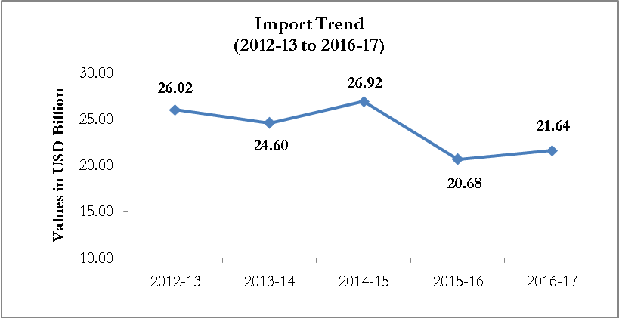

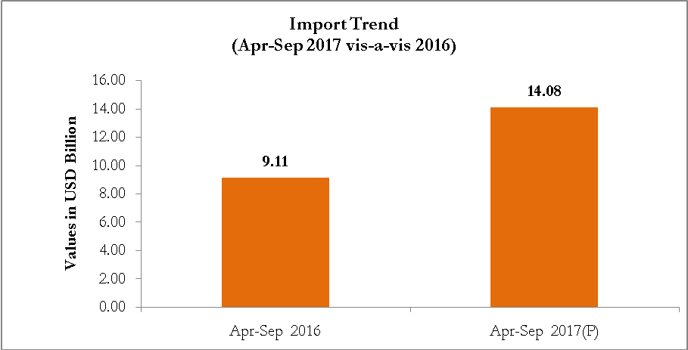

1.2 COMPOSITION OF IMPORTS OF ORES & MINERALS

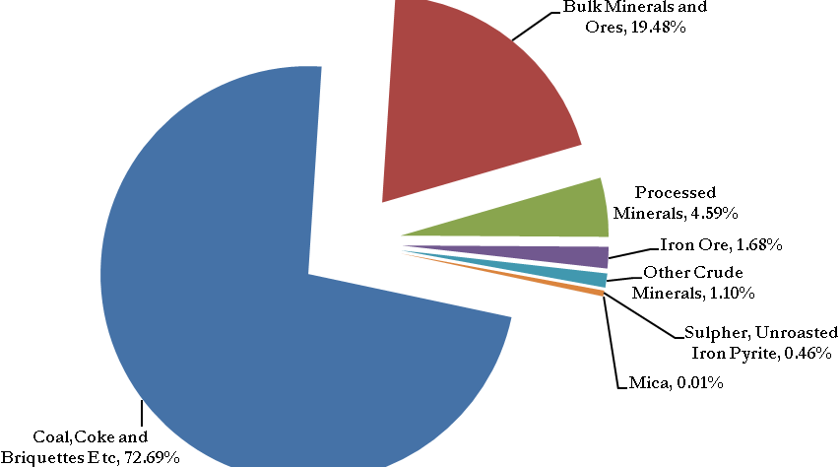

Major Composition of Imports of Ores & Minerals
(Occupying nearly 95% share of overall imports of this sector)

- Coal, Coke and Briquettes, Etc

- Bulk Minerals and Ores

- Processed Minerals

1.3 IDENTIFYING FOCUS ITEMS OF IMPORT
To formulate appropriate strategies for curbing the rise in imports of Ores & Minerals, specific focus items; i.e., at 8-digit HS level have been identified.

- COAL, COKE AND BRIQUETTES, ETC

Major item of India’s concern/attention

(Values in USD Mn & Qty in Thousands)

HS Code | Commodity | 2015-16 |  | 2016-17 |  | %Growth in Value | Apr-Aug 2016 |  | Apr-Aug 2017 |  | %Growth in Value
HS Code | Commodity | Value | Qty | Value | Qty | %Growth in Value | Value | Qty | Value | Qty | %Growth in Value
27011910 | COKING COAL | 4329.92 | 44,561.17 | 6138.37 | 41,643.79 | 41.77% | 1,578.37 | 17,103.05 | 3,608.72 | 18,876.28 | 128.64%
27011920 | STEAM COAL | 6794.07 | 127,613.51 | 7115.04 | 127,993.25 | 4.72% | 2,801.73 | 59,285.14 | 3,596.34 | 55,331.13 | 28.36%

Steam Coal (27011920)  and  Coking Coal (27011910) | - occupied nearly 85% share in India’s total import of Coal, Coke & Briquettes, etc. and
Steam Coal (27011920)  and  Coking Coal (27011910) | Major import sources include  - Indonesia: USD 2.1 bn  - South Africa: USD 1 bn

- Only Items with sizeable imports (USD 10 mn or more) and with high growth in imports have been taken
- Import sources covered contribute to nearly 90% of India’s imports in respective tariff line

- BULK MINERALS AND ORES

Major item of India’s concern/attention

(Values in USD Mn & Qty in Thousands)
HS Code | Commodity | 2015-16 |  | 2016-17 |  | %Growth in Value | Apr-Aug 2016 |  | Apr-Aug 2017 |  | %Growth in Value
HS Code | Commodity | Value | Qty | Value | Qty | %Growth in Value | Value | Qty | Value | Qty | %Growth in Value
26030000 | COPPER ORES AND CONCENTRATES | 4037.85 | 1,886,199.53 | 2725.96 | 1,143,215.78 | -32.49% | 947.34 | 413,168.46 | 1,531.04 | 556,300.23 | 61.61%
25210090 | LIMESTONE OTHR THN LIMESTONE FLUX | 212.33 | 11,181,693.63 | 228.71 | 12,517,716.40 | 7.71% | 93.07 | 5,166,077.60 | 120.18 | 6,097,526.26 | 29.13%
26020040 | MANGANESE ORE (<40 BUT >=35%) | 73.62 | 721,445.21 | 77.71 | 444,488.69 | 5.56% | 21.94 | 177,932.58 | 91.25 | 488,089.97 | 315.91%
26020090 | OTHER MANGANESE ORES AND CONCENTRATES | 1.2 | 15,112.17 | 81.03 | 380,053.00 | 6652.50% | 10 | 72,580.00 | 72.69 | 395,653.87 | 626.90%
26020030 | MNGANSE ORE(<44 BUT>OR EQL TO 40 PRCNT) | 22.84 | 172,736.89 | 35 | 223,191.79 | 53.24% | 17.86 | 140,239.65 | 35.30 | 167,471.66 | 97.65%
26020020 | MANGANESE ORE (<46 BUT> OR = 44 PRCNT) | 64.33 | 491,803.49 | 74.4 | 390,400.96 | 15.65% | 19.94 | 166,445.96 | 34.11 | 143,199.00 | 71.06%
26020050 | MANGANESE ORE (<35% BUT>=30%) | 21.05 | 199,507.84 | 11.89 | 90,338.50 | -43.52% | 2.5 | 25,014.00 | 34 | 234,324.56 | 1260.00%
26131000 | MOLYBDNUM ORES AND CONCENTRATES ROASTED | 73.92 | 7,368.66 | 79.77 | 6,915.64 | 7.91% | 30.5 | 2,774.52 | 49.4 | 3,734.43 | 61.97%
25221000 | QUICKLIME | 47.06 | 464,308.27 | 45.23 | 491,609.24 | -3.89% | 16.9 | 180,340.17 | 21.24 | 230,540.49 | 25.68%
26100020 | CHROME ORE LUMPS CONTNG 40% OR MORE BUT BELOW 47% CR2O3 | 16.76 | 74,680.10 | 17.55 | 71,075.00 | 4.71% | 6.2 | 30,169.00 | 13.3 | 32,837.00 | 114.52%

 | HS Code | Commodity | IMPORT SOURCES
COPPER | 26030000 | COPPER ORES AND CONCENTRATES | Chile, Indonesia, Peru Brazil
LIMESTONE | 25210090 | LIMESTONE OTHR THN LIMESTONE FLUX | UAE, Oman
MANGANESE | 26020040 | MANGANESE ORE (<40 BUT >=35%) | South Africa, Gabon
MANGANESE | 26020090 | OTHER MANGANESE ORES AND CONCENTRATES | South Africa, Australia
MANGANESE | 26020030 | MNGANSE ORE(<44 BUT>OR EQL TO 40 PRCNT) | South Africa
MANGANESE | 26020020 | MANGANESE ORE (<46 BUT> OR = 44 PRCNT) | Gabon, South Africa, Australia
MANGANESE | 26020050 | MANGANESE ORE (<35% BUT>=30%) | South Africa, Gabon
MOLYBEDNUM | 26131000 | MOLYBDNUM ORES AND CONCENTRATES ROASTED | Thailand, Chile, Korea, USA
QUICKLIME | 25221000 | QUICKLIME | Oman, Vietnam, Malaysia
CHROME | 26100020 | CHROME ORE LUMPS CONTNG 40% OR MORE BUT BELOW 47% CR2O3 | South Africa

- Only Items with sizeable imports (USD 10 mn or more) and with high growth in imports have been taken
- Import sources covered contribute to nearly 90% of India’s imports in respective tariff line

- PROCESSED MINERALS

Major item of India’s concern/attention

(Values in USD Mn & Qty in Thousands)

HS Code | Commodity | 2015-16 |  | 2016-17 |  | %Growth in Value | Apr-Aug 2016 |  | Apr-Aug 2017 |  | %Growth in Value
HS Code | Commodity | Value | Qty | Value | Qty | %Growth in Value | Value | Qty | Value | Qty | %Growth in Value
28182010 | ALUMINA CALCINED | 284.17 | 921,601.87 | 416.8 | 1,298,047.03 | 46.67% | 145.46 | 524,756.75 | 281.83 | 807,968.66 | 93.75%
28182090 | OTHER ALUMINIUM OXIDE | 67.33 | 76,844.95 | 82.48 | 105,522.99 | 22.50% | 36.4 | 46,107.77 | 39.22 | 52,140.31 | 7.75%
25201010 | NATURAL GYPSUM AND ANHYDRITE | 75.14 | 3,887,685.01 | 77.19 | 4,210,634.29 | 2.73% | 34.61 | 1,920,059.70 | 46.65 | 2,260,653.30 | 34.79%
28211010 | IRON OXIDES | 30.26 | 46,363.87 | 29.51 | 26,811.92 | -2.48% | 14.21 | 12,604.53 | 14.96 | 12,886.41 | 5.28%
25084010 | BALL CLAY | 19.85 | 167,856.06 | 20.44 | 173,357.88 | 2.97% | 8.58 | 70,591.39 | 12.56 | 104,222.23 | 46.39%
25070029 | OTHER KAOLINE NES | 15.78 | 50,510.75 | 18.59 | 57,842.24 | 17.81% | 8.03 | 25,768.27 | 11.16 | 34,875.95 | 38.98%

HS Code | Commodity | IMPORT SOURCES
28182010 | ALUMINA CALCINED | Australia, Vietnam
28182090 | OTHER ALUMINIUM OXIDE | China
25201010 | NATURAL GYPSUM AND ANHYDRITE | Oman, Iran, Pakistan
28211010 | IRON OXIDES | China, Germany
25084010 | BALL CLAY | Ukraine
25070029 | OTHER KAOLINE NES | USA

- Only Items with sizeable imports (USD 10 mn or more) and with high growth in imports have been taken
- Import sources covered contribute to nearly 90% of India’s imports in respective tariff line

1.4 REASONS FOR IMPORT GROWTH IN ORES & MINERALS

(To be detailed by Federation of Indian Mineral Industries, CAPEXCIL and other related trade bodies)

- STEAM COAL AND COKING COAL

- COPPER

- LIMESTONE

- MANGANESE

- MOLYBEDNUM

- QUICKLIME

- CHROME

- ALUMINA CALCINED

- NATURAL GYPSUM AND ANHYDRITE

- BALL CLAY

- OTHER KAOLINE NES
2. INDIA’S EXPORTS OF ORES & MINERALS

2.1 OVERVIEW:

- This segment constitutes a share of 0.99% in India’s global exports during Apr-Sep 2017.

- During 2012-13 to 2016-17, India’s exports of Ores & Mineral witnessed a negative CAGR of – 3.03%.

- However, India’s exports of Ores & Minerals increased by a double digit growth of 61.58% in 2016-17 and have continued to project a positive growth with 18.14% during FY Apr- Sep period.

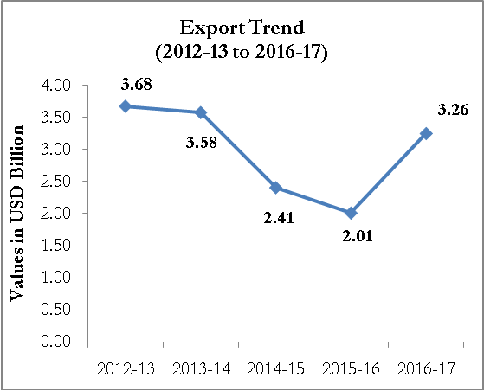

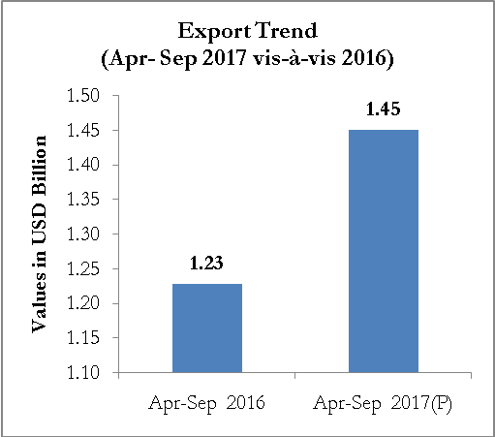

2.2 COMPOSITION OF EXPORTS OF ORES & MINERALS

