R   | (Sponsored by Ministry of Commerce & Industry,  Government of India)  “Vanijya Bhavan”, International Trade Facilitation Centre,  1/1 Wood Street, 3rd Floor, Kolkata-700016
कैपेक्सिल  CAPEXIL | *Tel: 033 -2289-1721/22/23/25, *Fax: 2289-1724,  * E-mail: capexil@capexil.in,  *Web: www.capexil.com /www.capexil.org  *PAN: AAACC9959R, *CIN: U36900WB1958NPL023786 | FS 70972  ISO 9001:2008

Ref: CAPEXIL/ MEM/ BKR/ 1354 Dated 16th November, 2016

TO ALL MEMBERS OF CAPEXIL,

Dear Sirs,

Sub.: Enhancement of Membership Fees, Renewal of Membership of CAPEXIL for the year 2017-18
and Steps for enrolling in New Automation Membership Application at https://membership.capexil.org.

At the outset, CAPEXIL is grateful to you for your continued patronage as a member.

As you are aware that Registration-Cum-Membership Certificate (RCMC) may be cancelled for those members who have not paid their subscription “in full” including Service Tax. Payment of Membership Subscription is due on 1st April in each Financial Year. To avoid such possibility of cancellation members may remit their membership subscription for the year 2017-2018 as early as possible. Over and above for exercising voting right and other privileges members must pay their membership subscription by 30th April of the Financial Year.

As per decision of Competent Authority of the CAPEXIL, Membership subscription from the F.Y. 2017-18 as per details given below:-

Small Scale category |  | Large Scale category
Manufacturer | Merchant | Manufacturer | Merchant
Registered with State Director of Industries/ District Industries Centre as SSI/ Micro/ Tiny unit. | Export turnover below Rs. 25 Lacs for CAPEXIL items in both of two preceding years | Other than SSI/ Micro/ Tiny unit i.e. Medium Large. | Export turnover of Rs.25 Lacs or above for CAPEXIL items in either of two preceding years.
7500.00 (Plus S.Tax) |  | 14000.00 (Plus S. Tax)

Those who have already paid their membership fees for the year 2017-18 and onwards are requested to kindly pay the balance amount. Members who have not paid Membership Subscription for any previous years (before F.Y. 2017-18), are requested to kindly send us the same at previous subscription alongwith applicable taxes.

For the purpose of renewal, we are enclosing herewith membership renewal Proforma Invoice for the financial year 2017-18 for your information and payment. You are requested to update your company profile in CAPEXIL’s New Automation Membership Application at https://membership.capexil.org

With best regards,
Yours sincerely,
Sd/-

(B.K. Roy)
Membership Incharge
CAPEXIL, KOLKATA
Email: bkroy@capexil.in

Encl.: Proforma Invoice & steps to enroll in our New Automation Membership Application at https://membership.capexil.org

Please ignore the attached Proforma Invoice
if you have already paid membership fee for the year 2017-18 at revised rate.

CAPEXIL
RENEWAL - PROFORMA INVOICE (F.Y. 2017-2018)

M/s. | Service Tax Reg. No.: AAACC9959RSD003
Address: | P. Invoice No.: MEM-REN/2017-18/1354/
Address: | Date: November16, 2016  PAN: AAACC9959R,  CIN: U36900WB1958NPL023786  Membership Code:

Please select your category from below mentioned table and arrange to send membership subscription:

Option | Particulars | Member  ship  Subscrip-  tion | DUAL  RCMC Charges | Additional  Panel charges | Total | Service Tax Incl. SBC & KKC | Total Membership Payable incl. Taxes | Option  to be selected
1 | SCM | 7500 | 0 | 0 | 7500 | 1125 | 8625
2 | SCM + DR | 7500 | 1000 | 0 | 8500 | 1275 | 9775
3 | SCM + DR + 1 AP | 7500 | 1000 | 1000 | 9500 | 1425 | 10925
4 | SCM + DR + 2 APs | 7500 | 1000 | 2000 | 10500 | 1575 | 12075
5 | SCM + 1 AP | 7500 | 0 | 1000 | 8500 | 1275 | 9775
6 | SCM + 2 APs | 7500 | 0 | 2000 | 9500 | 1425 | 10925
7 | LCM | 14000 | 0 | 0 | 14000 | 2100 | 16100
8 | LCM + DR | 14000 | 1000 | 0 | 15000 | 2250 | 17250
9 | LCM + DR + 1 AP | 14000 | 1000 | 1000 | 16000 | 2400 | 18400
10 | LCM + DR + 2 APs | 14000 | 1000 | 2000 | 17000 | 2550 | 19550
11 | LCM + 1 AP | 14000 | 0 | 1000 | 15000 | 2250 | 17250
12 | LCM + 2 APs | 14000 | 0 | 2000 | 16000 | 2400 | 18400

Note:
SCM: Small Category Member, (Small Merchant Exporter, Small Manufacturer Exporter)
LCM: Large Category Member, (Large Merchant Exporter, Large Manufacturer Exporter)
AP: Additional Panel,
DR: Dual RCMC (Merchant-Cum-Manufacturer Exporter)

Mandatory Requirement for Small Scale category**
Manufacturer/Publishers Exporter must send a copy of SSI Certificate/Industrial License
Merchant Exporter must send a Chartered Accountant’s Certificate certifying the export turnover of CAPEXIL Product for last 2 years.

The payment should be made in Demand Draft, Cheque in favour of CAPEXIL, payable at Kolkata (other than Outstation & Non CTS cheque), or through RTGS/NEFT in the below bank:

Kotak Mahindra Bank Limited,  H.B.SARANI BRANCH  IFSC Code: KKBK0000958  SB A/C No. 504010190346  Beneficiary Name: CAPEXIL | Indian Oversea Bank,  I.B. BRANCH  IFSC Code: IOBA0000585  SB A/C No. 058501000074371  Beneficiary Name: CAPEXIL

Kindly do not deposit cheque directly to Bank.

Membership Subscription Fees Information:

Annual Subscription for renewal of Membership (Rs.) |  | Small Scale category** | Large Scale category
 |  | Manufacturer: Registered with State Director of Industries/ District Industries Centre as SSI/ Micro/ Tiny unit.  Merchant: Export turnover below Rs. 25 Lacs for CAPEXIL items in both of two preceding years. | Manufacturer: Other than SSI/ Micro/ Tiny unit i.e. Medium Large.  Merchant: Export turnover of Rs.25 Lacs or above for CAPEXIL items in either of two preceding years.
Business Auxiliary & Support Services: Membership Subscription (2017-18) |  | 7500.00 | 14000.00
Service Tax @ 14% |  | 1050.00 | 1960.00
Swachh Bharat Cess @ 0.5%  Krishi Kalyan Cess@ 0.5% |  | 37.50  37.50 | 70.00  70.00
Total Membership Payable |  | 8625.00 | 16100.00
Dual RCMC: | Rs. 1000.00 for once in every five years + Service Tax @ 14% + SBC @ 0.5% + KKC @ 0.5% , Total :Rs. 1150/-
Additional panel: | Rs. 1000.00 per panel + Service Tax @ 14% + SBC @ 0.5% + KKC @0.5%, Total :Rs. 1150/-

Note:

- Dual RCMC fee is charged on Manufacturer-cum-Merchant exporter @ of Rs. 1000.00 (Plus applicable taxes) once in every five years and Additional Panel is charged @ of Rs. 1000.00 per panel (plus applicable taxes)

- If payment is made via RTGS/NEFT then the details should be send with a subject of "ONLINE PAYMENT" alongwith concerned attachment to the following mail:
bkroy@capexil.in, sb.nandi@capexil.in, bn.biswas@capexil.in and membership@capexil.in

- Please send your RCMC alongwith applicable membership subscription to the respective Regional Offices of the Council for necessary endorsement/revalidation.

This is a computer generated Proforma Invoice.

We are delighted to officially announce the launch of our
Membership Automation web application.
You can now find us at https://membership.capexil.org.
You have been a member of Capexil, and in order to serve you better, Council is pleased to announce the launch of the new system. It should enable you, our valued patron, to locate information about your profile with respect to your Membership with us, and associated services quickly and easily!
Be rest assured, your data shall remain fully secure as we've implemented an encrypted connection allowing your private information to be transmitted without the problems of eavesdropping, data tampering, or message forgery
- We did send automated invites to all the members on their email addresses with us. Please check your Inbox or Junk/Spam folder.
- In case you haven't received the registration invite, please drop us an email with your company name, existing RCMC number and your email at itsupport@capexil.in, bkroy@capexil.in
- We would then send you a fresh registration invite!
- Once you accept the invite by clicking on the blue button in that email (as shown below), your login credentials will be sent to you immediately.
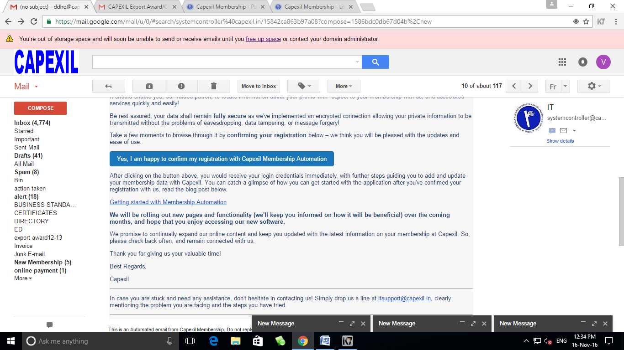
- You can catch a glimpse of how you can get started with the application after you've confirmed your registration with us.
- We will be rolling out new pages and functionality the coming months, and hope that you enjoy accessing our new software.
- We promise to continually expand our online content and keep you updated with the latest information on your membership at Capexil. So, please check back often, and remain connected with us.
Thank you for giving us your valuable time!!

